MARKET SUMMARY & Plan

Converting our green bottling investments into increased sales

Executive Summary
Our new marketing plan, outlined in this document, focuses on renewing both our relevance and appeal to our key targets through the integration of our environmental story. We are responding directly to our customers needs in this initiative—they have noted in both Aquo-conducted and independent research that manufacturers’ green values are becoming increasingly relevant to their purchase decisions.

In the crowded beverage marketplace, Aquo can differentiate itself through the quality and sustainability of our ingredients and the responsible manner in which our products are created and brought to market. Our marketing challenge is to present our green story to new and existing customers in an efficient and targeted campaign that raises our ROI through increased sales.

Our Vision
Aquo is working to produce the highest quality organic energy drink available in ways that won’t harm the Earth. Since our start in 2006, we have led the way for our industry in our agreements with local farmers, our stringent standards for our raw materials,
and our corporate policies on recycling and conservation. We’ve now applied the very
same green philosophy to our Southern California Bottling Facility & Headquarters,
a tangible example of Aquo’s environmental commitment that demonstrates the
value of green building to its customers, shareholders and business leaders worldwide.
Aquo waters will also now be bottled in a redesigned, reusable bottle, with an advanced carbon filtration mechanism built in.

We want our customers to feel good about the products they buy. Aquo’s drinks are healthy, refreshing, and taste great. We’ve worked to minimize the downsides of our consumer culture: waste produced in manufacturing, environmentally irresponsible business practices, and lower quality products in the market. Aquo drinks do good
for the both the people drinking them and the people producing them.

Target Market
Aquo’s target market is the hip, urban professional, 20s to 30s, worldwide. They
work hard and play hard, and like to contrast their working life with challenging outdoor adventures. They are environmentally aware and interested in making a difference. They have sophisticated tastes and humor, but are not frivolous in their lifestyles or purchases.

Competitive Analysis
Aquo’s market share in the energy drinks category has been steadily increasing since
the introduction of our products in 2006, and currently hovers around approximately 15% of US sales, 10% of European sales, and 7% of Asian sales. We do believe, however, that increased marketing efforts are needed to maintain this growth, due to ever-increasing competition from other organic brands.

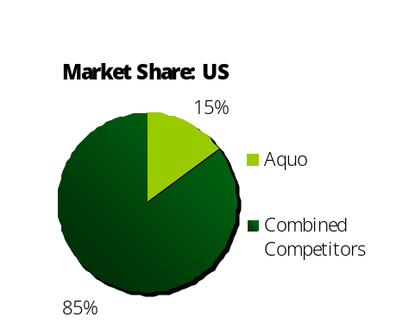

Product Segmentation
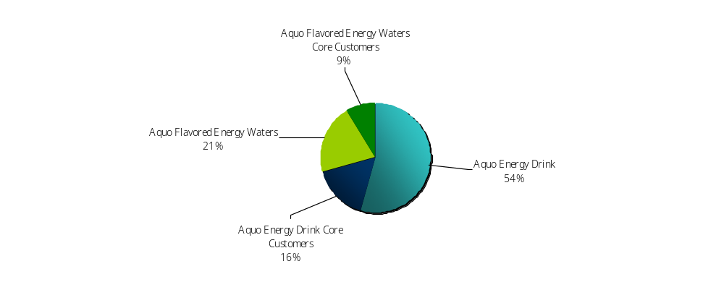Aquo currently offers two main product lines: juice-based energy drinks and flavored energy waters. We’ve found through our sales research that each type of product
has a strong core customer base accounting for approximately 30% of total sales
for that line. Aquo energy drink sales comprise approximately 30% of total sales for
that line. Aquo energy drink sales comprise approximately 65% of overall sales
for the company, and Aquo flavored energy waters comprise the remaining 35%.

Marketing Objectives
- Increase overall sales by 10%, and domestic US sales by 20%.
- Increase gross margin to 25% or more.
- Increase Aquo water sales by 25%.

Marketing Strategy
While juice-based energy drink sales are likely to increase through a traditional campaign and packaging messaging, flavored water sales need to be fought for.
We need to convince the consumer of the benefit of our new packaging and bottling methods before our competitors attempt to gain prominence. Therefore a larger amount of our marketing budget and promotional efforts must go towards our
flavored energy waters.

Tactical Plans
Aquo’s marketing efforts will include updates to our web site, a new advertising campaign focusing on our green story and new water bottle, and in-person samples
and coupons distributed by the Aquo street team in 6 international cities.

Marketing Effort 1: Aquo Web Site Updates
Aquo will re-launch its website with a completely new design in Q2 of 2009. The Aquo Web Team will collect data and updates from the B/U’s, plant engineers and marketing department for semi-monthly updates to the site. Updates will include info on events, new product flavors and statistics on the bottling facility’s environmental impact.

Marketing Effort 2: Advertising
Aquo will launch a multi-tiered marketing campaign messaging our green initiatives
in Q2 of 2009. Print advertising in appropriate publications worldwide will be supplemented by a domestic on-air advertising campaign and strategically placed banner ads on lifestyle blogs and web sites. The campaigns will consist of the following:

• PRINT ADVERTISING
series of 5 full spread ads, 3 focusing on flavored waters and 2 focusing on juice-based energy drinks

• ON-AIR ADVERTISING
single 45 second Aquo commercial, featuring Thomas Booker speaking candidly about the new bottling plant and water bottle

• INTERNET BANNER ADS
series of 10 banner ads, 6 focusing on flavored waters and 4 focusing on juice-based energy drinks. Water-focused ads will have a click-through to a downloadable coupon good for a discounted flavored water (amount of discount TBD).

Marketing Effort 3: Aquo Street Team
Aquo is in the process of hiring “street teams” of 10-12 people in Los Angeles,
New York, London, Berlin, Hong Kong, and Tokyo. These teams will scout locations frequented by our target market consumers in those cities, and distribute samples
of Aquo flavors waters and coupons (amount of discount TBD). Street team will
be active for approximately 2 weeks in Q2 of 2009.

Advertising Budget (by Geo)
Aquo has a very aggressive print and broadcast slated for 2009. Based on Aquo past advertising models, and our current position in the energy drink market, Aquo will raise advertising spending 18%, with expectations of raising total quarterly sales over $285,000. Using this marketing plan Aquo can realistically plan to achieve an 11% profit margin by year’s end.

Keys to Success
Our main key to success in these effort will be to sincerely present the benefits of green manufacturing to our customers. We need to make sure that our story is compelling enough to be repeated, allowing word of mouth from our current consumers to bring
in new ones. We must convince the public that Aquo, the company, is a driving force for positive change; and by purchasing our products, the consumer is joining a movement towards a more responsible marketplace.

Measuring Results
By Q1 of 2010, Aquo should conduct a thorough analysis of sales to determine
the effectiveness of our marketing campaign, by Geo. A revised initiative should be determined at that time to further increase sales in any markets experiencing steady
or declined sales.

